**Apple Market Type**

* Oligopoly market
* Not too many players
* Pricing strategy of one company affects the pricing decision of another competitor

**Apple Competitors**

* Samsung
* Xiaomi
* Google
* IBM
* Microsoft
* Amazon

**Marketing Mix**

It is process through which the products or services are positioned strategically alongside competitor products and services through the control of product, price, place and promotion.

**Apple Marketing Mix Strategy**

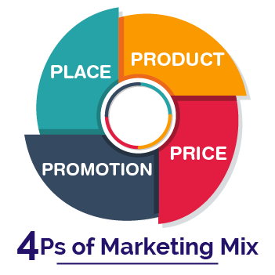

**Product**

* Mac
* Ipad
* iPhone
* Apple Watch
* Apple TV
* Air Tags.
* Air Pods
* Home Pod Mini

**Service**

Apple Tv+

Apple Music

Apple Arcade

iCloud

Apple Podcast

Apple Books

Wallet

**Price**

* Premium high priced
* No room for bargaining
* Resellers products are also high priced

**Promotion**

* Electronics Conclave
* Paid media
* 3rd party retailer advertisement
* Popular Tech bloggers
* Exclusive Apple launch event

**Place**

* Apple Stores
* Retail Stores
* Third-party cellular network carriers
* Wholesalers
* Resellers

**Market Research**

Market research helps to understand the dynamics of the market by understanding market share by volume and market share by value occupied by the competitors. It also helps to understand the target customers and how competitors are positioned in terms of product quality, price, customer satisfaction, brand value. This helps to identify market gaps through which products and services can be introduced that has competitive advantage.

**Apple Demographic Profile**

* Different from country to country
* Targeted age group 16 – 24 years
* People with high income and high to middle income are main targets
* More than 80% USA teens use iPhone

**SWOT Analysis**

SWOT analysis gives a quick evaluation of the current strength, weakness, opportunity and threat that are affected by both internal and external environments.

**Apple SWOT Analysis**

**Strength**

* Advanced Research and Development Team cherry-picked from best institutes
* Strong leadership in upper and middle management
* Excellent brand image

**Weakness**

* Very high price across all products and services
* No presence in cheap smartphone segment
* Accusation of using child labour in DRC.
* External supply chain outside USA subject to various risks.

**Opportunity**

Untapped cheap smartphone market

**Threat**

* Very high cost of service after sales thwarts potential sales from new customers.
* Reputation damage from accusation of child labour usage in DRC.
* Accusation of tax evasion can tarnish clean brand image.
* Loosing loyal customers due to very high cost of after sales service.

**PESTLE Analysis**

This analysis presents an understanding of the ways the external factors such as politics, economics, social norms, technology, environmental and legal are going to affect a business in a particular region.

**PESTLE Analysis of Apple**

**Political:**

* Extensive foreign country customer base increases exposure to risk.
* Present Ukraine-Russia can disrupt supply chain for sea route bound suppliers.
* This will stall the supply chain.
* Product manufacturing slowed down

**Economic**

* Businesses in countries faced with expanding sovereign debt can take a hit due to slowed down economy.

**Social**

* Countries that are still transitioning from one social phase to another can prove to be difficult to position Apple products.
* Developed countries that are already peaked out in social development progress offer ample scope for market penetration.
* Some developing countries still present a social construct that views Apple products as unnecessary accessories due to the huge disparity between their price and usefulness to daily life.

**Technological**

* No technological disadvantage present as such.
* Non-parity or non-alignment with sustainable development practices in technology can result in lawsuits in developing countries.

**Legal**

* Operations and financial conditions could be adversely impacted by unfavourable legal proceedings.
* Continued instances of a patent claim in cellular-enabled products.
* Patient holding companies can claim royalties from Apple and enter litigations

**Environmental**

* Apple services that are cloud-based can get affected and become non-operational due to any major environmental fallout such as hurricanes, tornadoes and storms.
* Disruption of power line meant to keep the cloud based servers up and running is also an issue without backup power plans

**Marketing Map**

This is a graphical representation of how the products and services of the competitors are positioned in a particular market and in that particular industry. This mapping helps a business find ways in which products and services can be passed on to the target customers

**Apple Marketing Map**

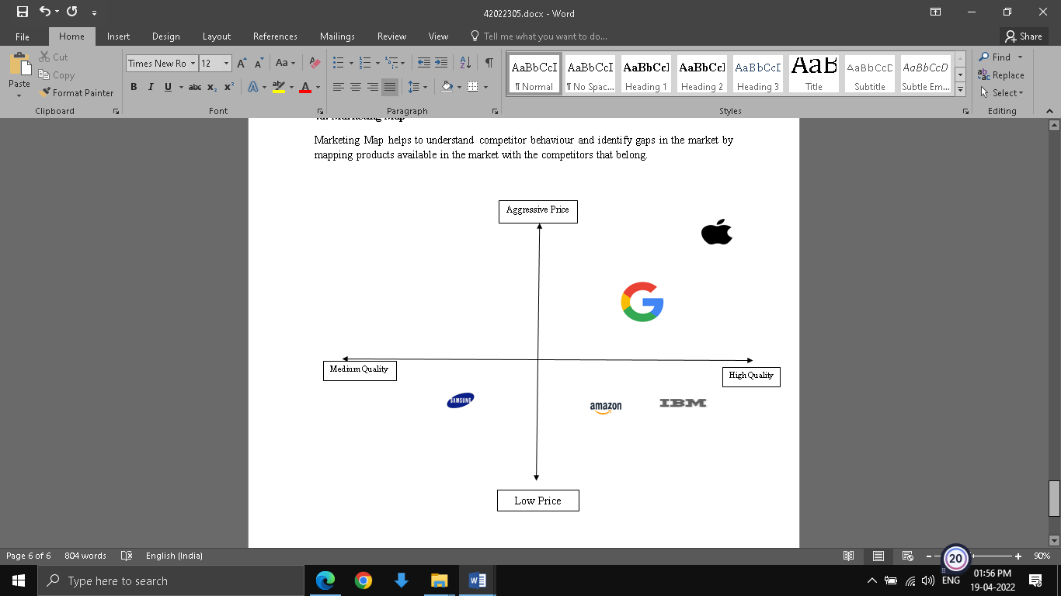

* Apple positioned in 1st quarter as high priced and high-quality product.
* Google also positioned in 1st quadrant as between high and medium price and subsequent quality also between high and medium price.
* Samsung only product to enjoy the tag of both medium-priced products with medium quality.
* Both Amazon and IBM are positioned as slightly low price but considerable high quality.
* Apple can foray int the medium price and medium quality segment in developing and still developing countries.

**Product Life Cycle**

Product life cycle tracks the development of a product or service from its inception, to its decline through subsequent steps of introduction, growth, maturity and decline. The stage are mapped across a time frame.

**Product life Cycle of Apple iPhone 11**

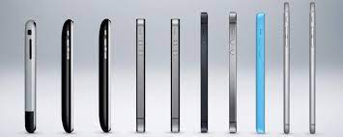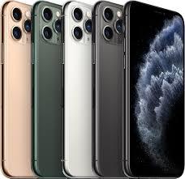

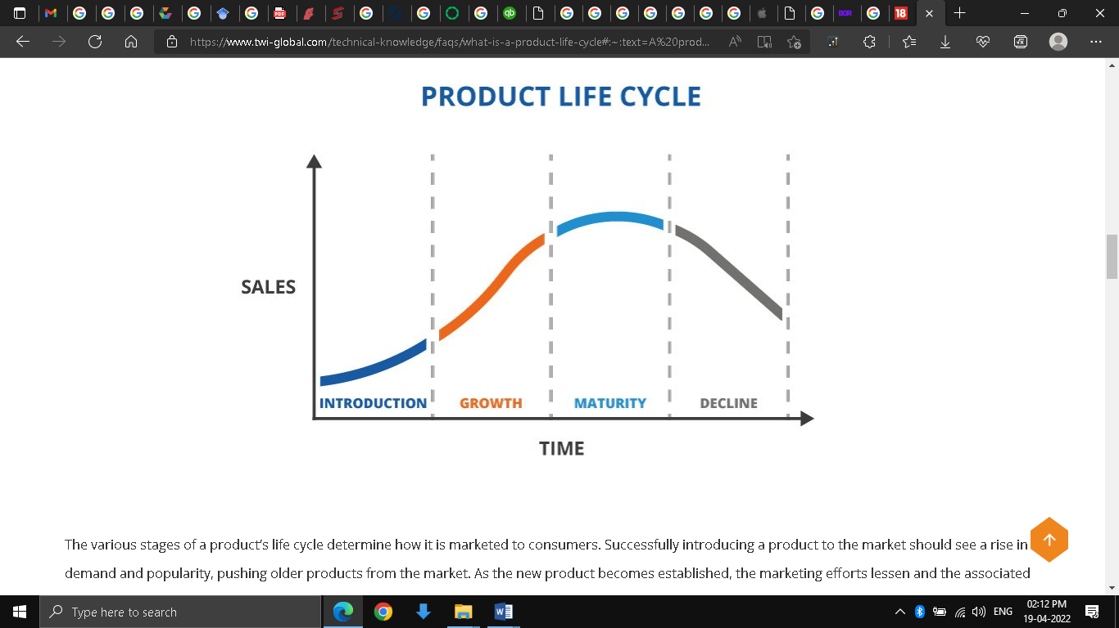

**Introduction**

* First official release date in September of 2019.
* Slow growth during the first launch phase.
* Slow growth as people still look at reviews from other user experiences.
* More emphasis on the promotional program for new product awareness.
* User experience takes time to generate as products like iPhone11 usually take more time.
* More time is attributed to higher brand value as users do not rush opine views for products with higher brand value.

**Growth**

* This is the growth phase as reviews and opinions start shaping.
* Reviews and opinions take time to be channelized through the use of the available medium in written, audio or both audio-video formats.
* People take time to do proper research of review to develop a holistic opinion.
* This culminates to order placement for new iPhone 11.
* Increased demand for the new iPhone 11 is met with a subsequent increase in supply.
* The demand and supply curve is not very linear in nature.
* Increased reviews, increased demand, increased product supply and finally increased sales finally pick momentum for iPhone11.
* iPhone 11 was reviewed as the most popular iPhone till date surpassing all sales in 2020
* More emphasis on new iPhone 11 stocking in stores and retail shops.

**Maturity**

* The market starts getting slowly saturated with potential iPhone1 1 users.
* Reviews keep generating but the number of people checking reviews keeps getting low.
* Any kind of minor product improvements such as a new colour announcement or the addition of extra software features are incorporated in this segment.
* As demands keep getting low, supply is also reduced and normalized.
* More emphasis on stocking iPhone11 necessary accessories in shops and service outlets
* Less emphasis on fresh stocking of iPhone11.

**Decline**

* Product phasing out
* Stopping production all together.
* Sales from fresh stocks very few.
* More reseller activity.
* Iphone 11 will b stopped after release of iPhone 14 by end of 2022.

**PR(Public Relations)**

It is the process through which organisations convey a message to the public regarding new product or service offerings or any other important news.

**Apple PR Strategy**

**Secrecy**

* No actual news leaked by Apple.
* Gives rise to more doubts and speculation.
* Eg. Announced iPhone 12 launch just 1 week ahead with no prior intimidation.

**Scarcity**

* Keep less stock during first/initial release deliberately
* Creates demand frenzy
* Longer ques in front of shops
* E.g. All new apple product launches bears the signature of long lines in Apple Stores

**Attract Apple Fans**

* Fans with similar passion with regards to innovation, simplicity and coolness.

**Link brand with famous innovators**

* Creative Figures,
* Actors,
* Musicians,
* Talented Artists.

**Business Ethics**

Certain rules and regulations that the business has to follow in order to meet the legal guidelines and mandates of the local region.

**Its Importance**

* Control business decisions according to local rules and regulations.
* Differentiate between acceptable and unacceptable actions.
* Increase transparency among all members

**Apple Business Ethics Criticism**

* Use of child labour in cobalt mining small artisanal industry of DRC that resulted in injury and death.
* Use of cheap labour based out of China at the cost of very low payment, inhuman working conditions and practices that threaten the environment.
* No definite target value declared by Apple in its effort of reduce PVC and other harmful product.
* Signs of tax evasion as no definite statement about tax paid in subsidiaries based out of Ireland, Singapore.